1. CREATE & INSERT

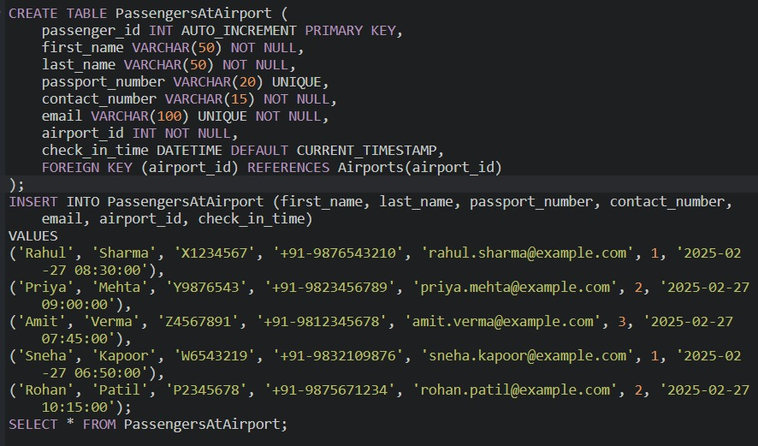

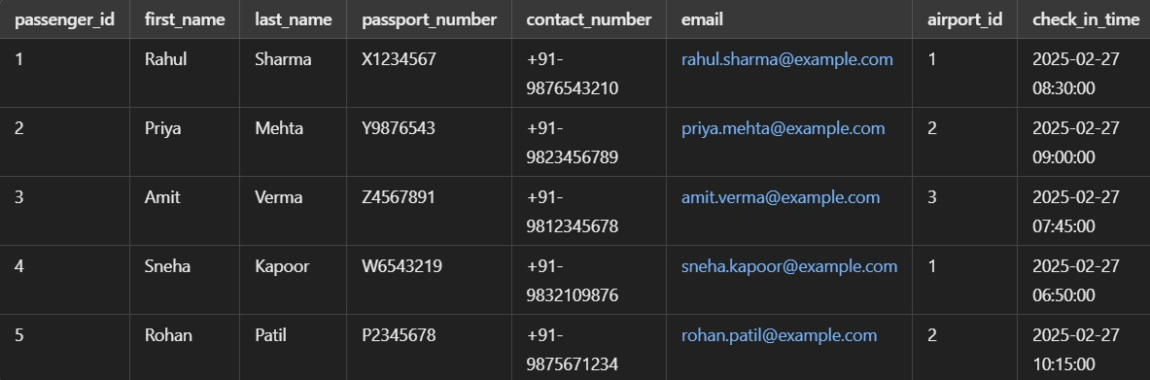

1. UPDATE

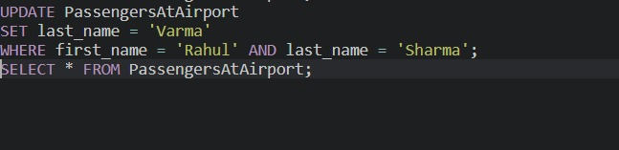

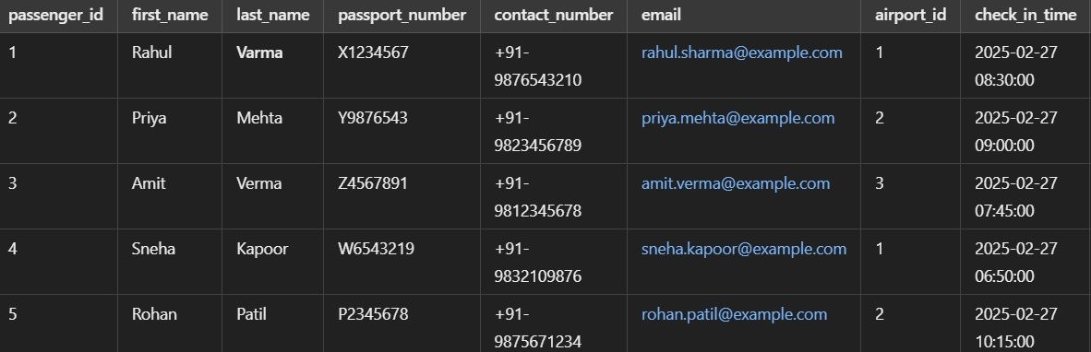

1. DELETE

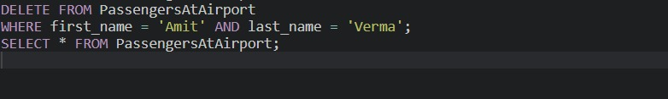

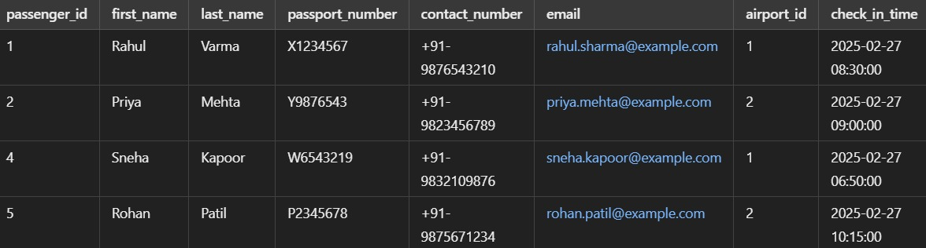

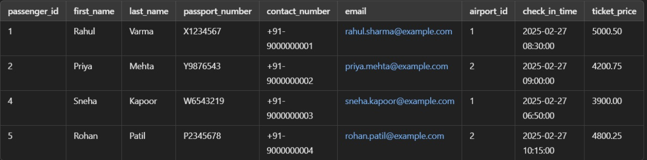

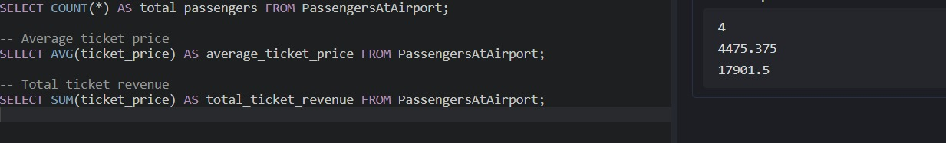

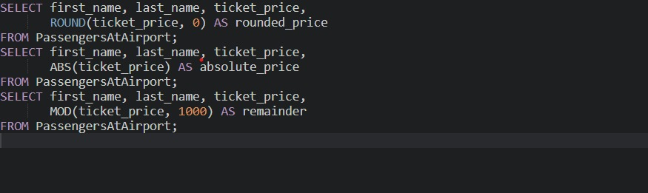

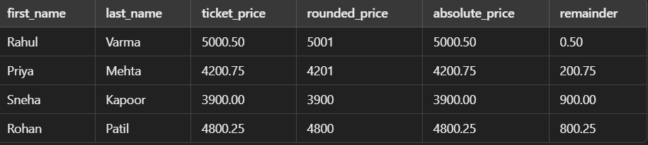

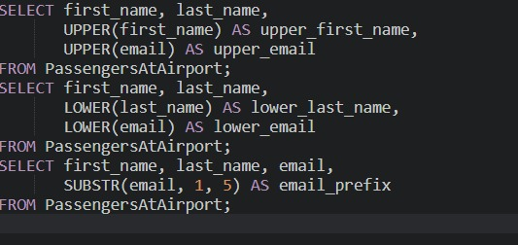



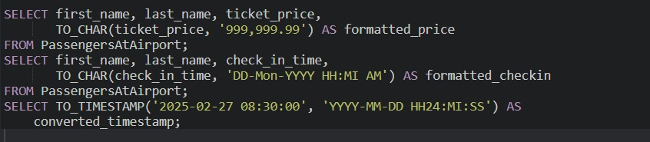

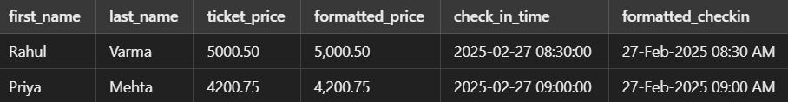

AND

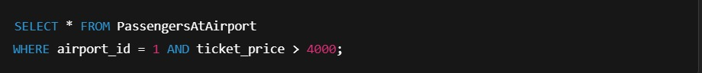



OR

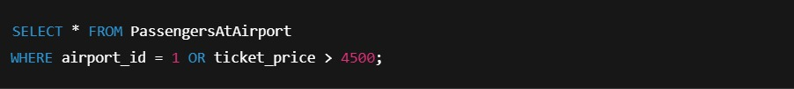

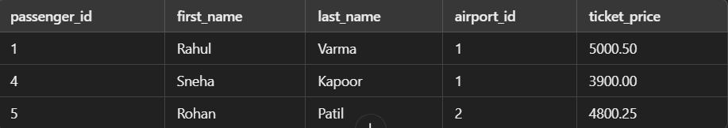

NOT



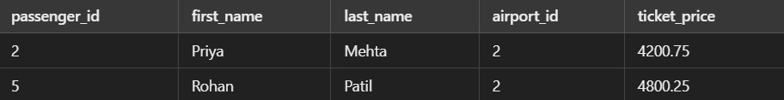

LIKE



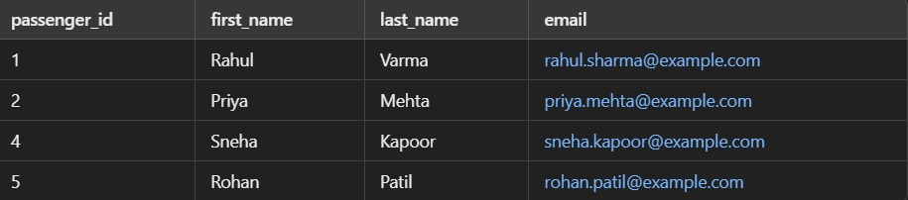

BETWEEN



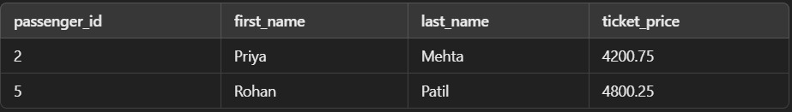

IN

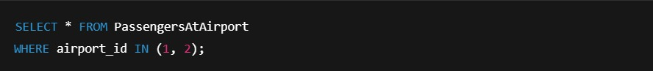

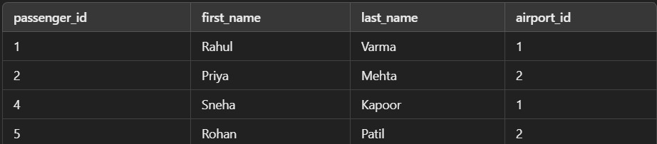

SUBQUERIES

1. Passengers who have completed payment

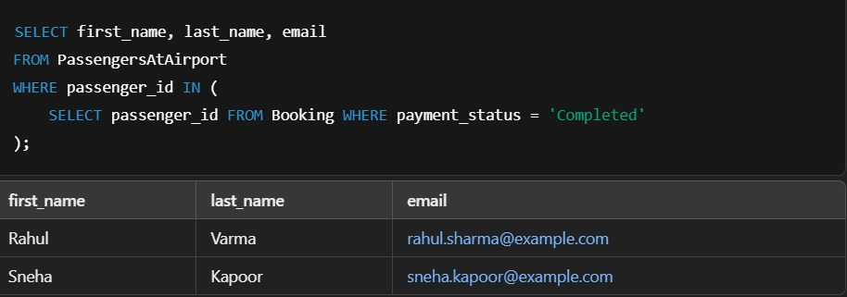

1. Flights where payment is still pending

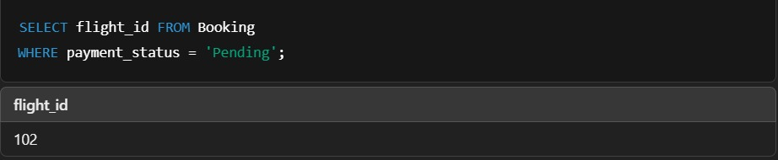

1. Passenger with the highest ticket price

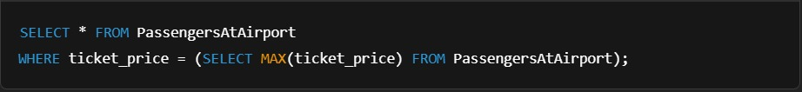

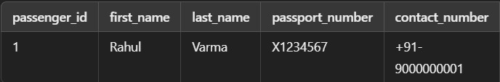

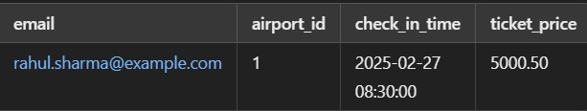

JOINS

Inner join – passengers with their booking details

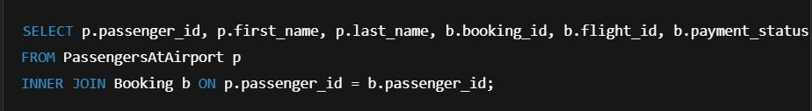

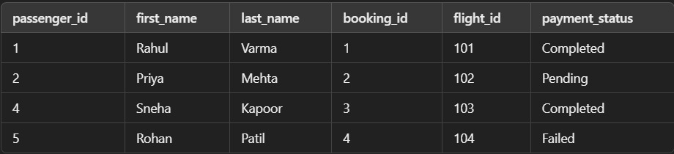

Left join – Show all passengers and their booking info

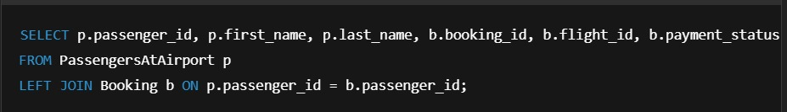

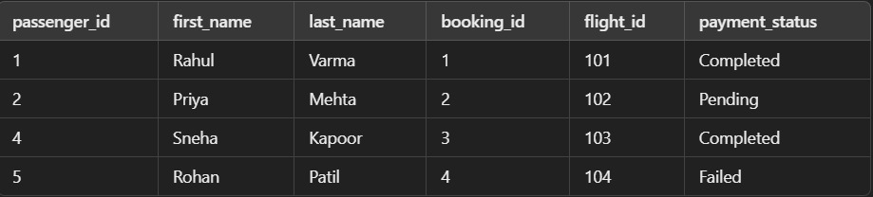

Right join – Show all bookings and their passenger info

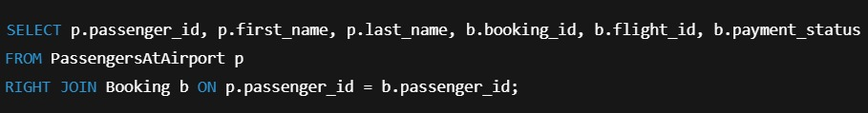

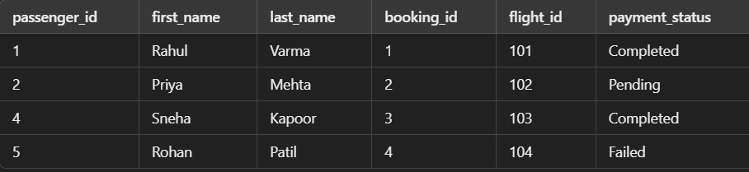

Full outer join – show all passengers and booking

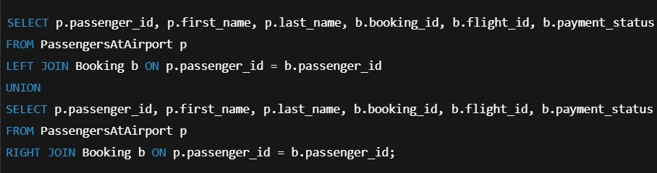

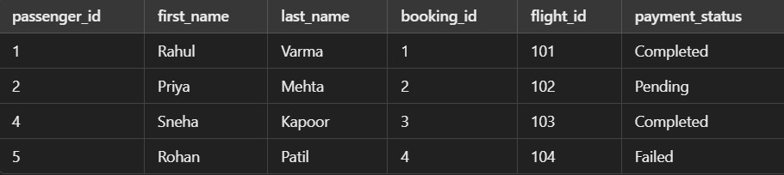

Natural join



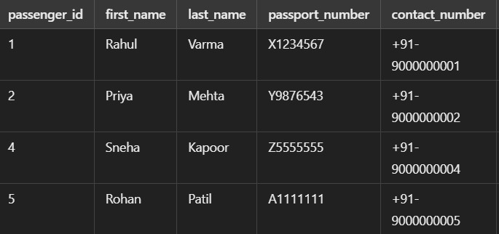

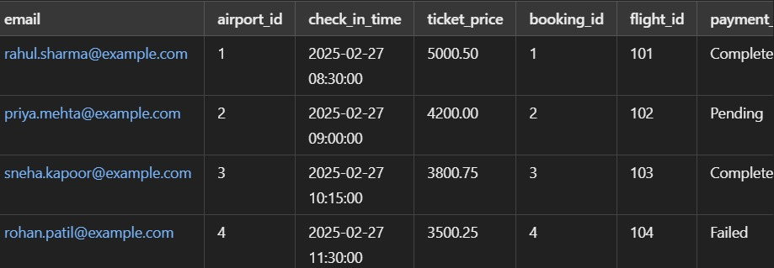

Semi join

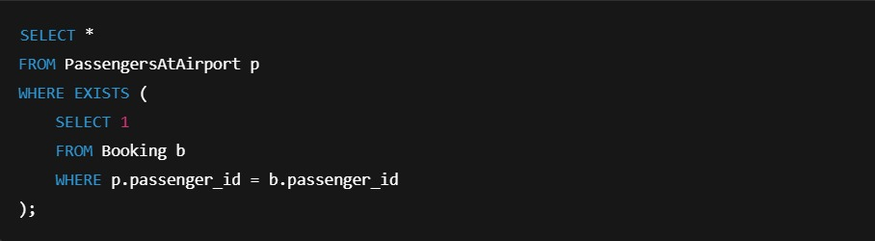

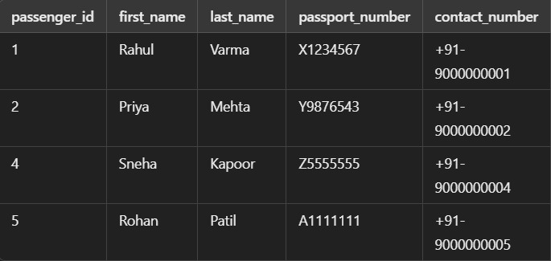

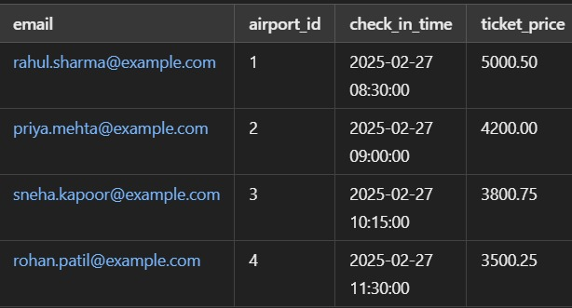

Anti join

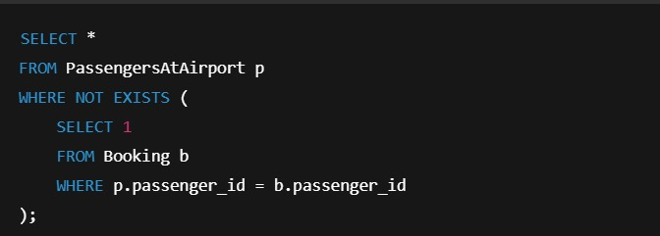

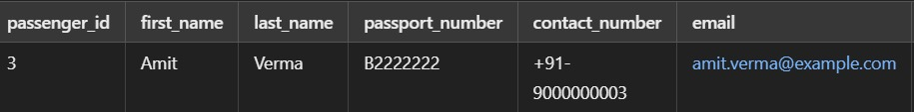

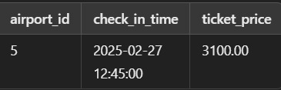

Theta join

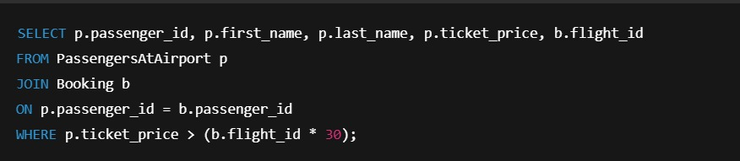

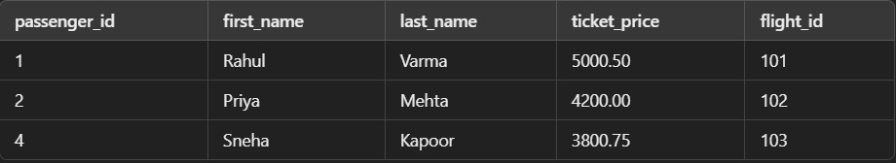

Division join

